**Part 1: Getting Comfortable with Linux**

**A. Introduction to Linux & Distributions**

* Demo: cat /etc/os-release to check current distro.

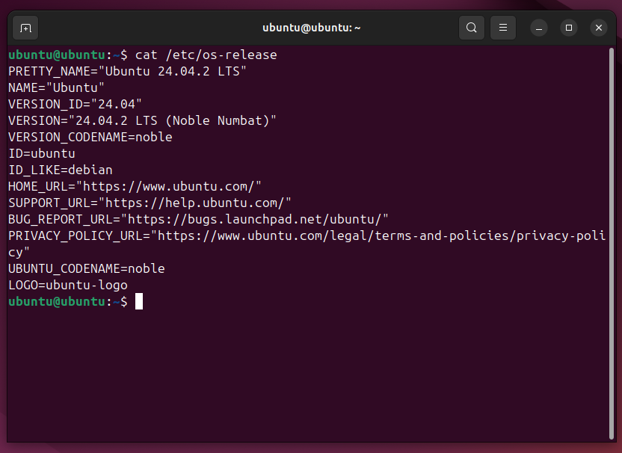

**B. Terminal Navigation & File Handling**

**Objective**: Learn to navigate file system and manipulate files.

**Tasks:**

**Navigate directories**

1. Pwd
2. ls -l
3. cd /tmp
4. mkdir linux_practice
5. cd linux_practice

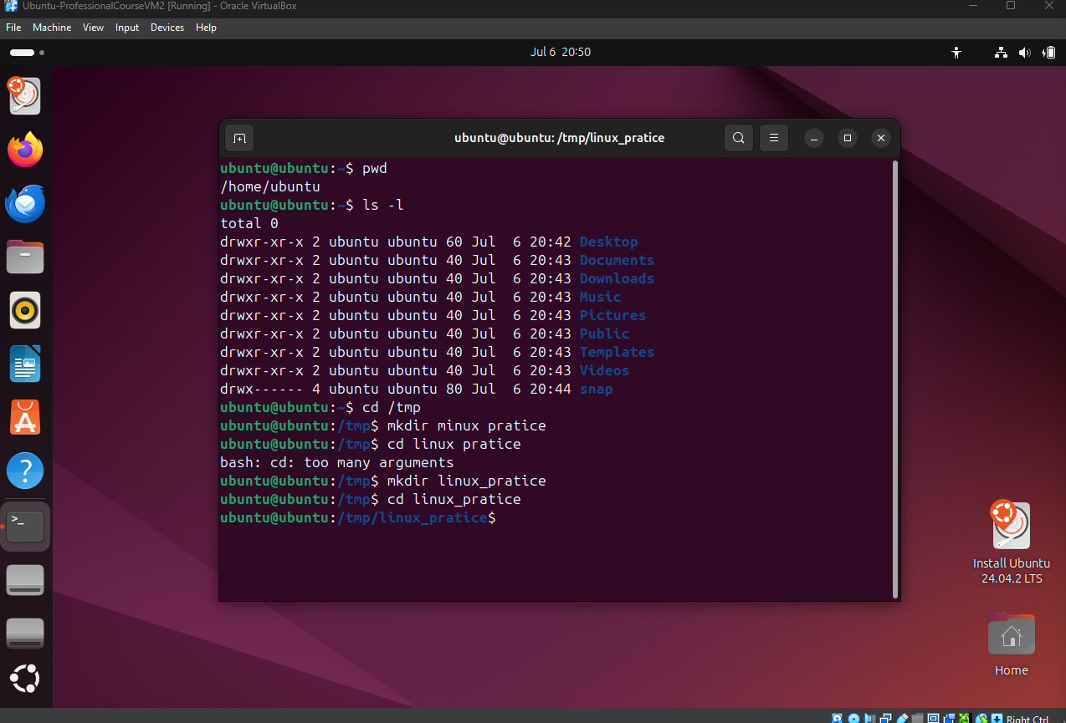

**File operations**

1. touch file1.txt file2.txt
2. echo "Hello Linux!" > file1.txt
3. cat file1.txt
4. cp file1.txt copy_file1.txt
5. mv file2.txt renamed_file2.txt
6. rm renamed_file2.txt  
     
   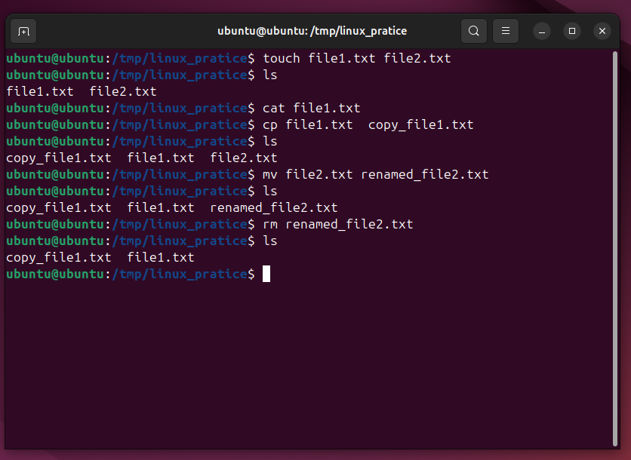

**C. Users, Groups, Permissions**

**Objective**: Understand access control in Linux.

**Tasks:**

**Permissions**

1. ls -l

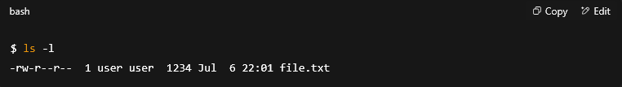

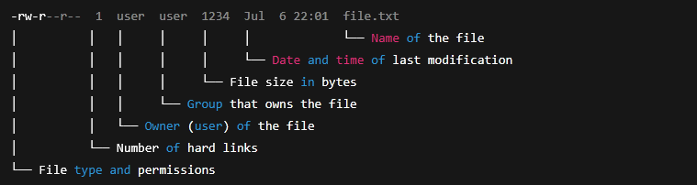

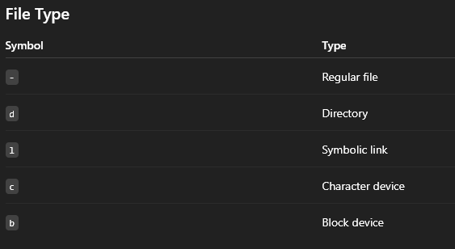

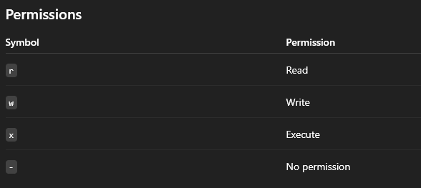

#### Example: -rw-r--r--

* - → Regular file
* rw- → Owner can read & write
* r-- → Group can only read
* r-- → Others can only read

1. chmod 644 file1.txt

* 664 ( rw-rw-r-- ) **enables read and write for the owner, read and write for the group, and read for others**.

1. chmod +x file1.txt

* The chmod +x command specifically **adds the execute permission**

**Ownership**

1. sudo chown $USER:$USER file1.txt

**User and group**

1. whoami
2. groups

**✍️ Part 2: Text Editors & Environment Variables**

**A. Editing with nano**

**nano task:**

nano notes.txt

# Add "Linux is fun!" and save using Ctrl+O, Enter, Ctrl+X

**B. Environment Variables**

**Tasks:**

echo $HOME

export MY_VAR="Test123"

echo $MY_VAR

env | grep MY_VAR

#grep is kind of a search function for admins

**🧪 Part 3: Basic Bash Scripting & Scheduling**

**A. Simple Bash Script**

**Create a script:**

nano hello.sh

# Add:

# #!/bin/bash

# echo "This script is working!"

chmod +x hello.sh

./hello.sh

**Task:** Modify script to:

* Accept name input using read
* Print current date

#!/bin/bash

read -p "Enter your name: " name

echo "Hi $name, today is $(date)"

**More info:**

Step 1: Create a New Script File

Open your terminal and run:

nano hello.sh

Step 2: Add the Initial Script Content

In the nano editor, type the following:

#!/bin/bash

read -p "Enter your name: " name

echo "Hi $name, today is $(date)"

Step 3: Make the Script Executable

Run the following command:

chmod +x hello.sh

Step 4: Run the Script

Execute it with:

./hello.sh

**B. crontab Scheduling**

**Task: Create a script that logs the date every minute**

nano datelog.sh

# Add:

# #!/bin/bash

# date >> ~/date_log.txt

chmod +x datelog.sh

crontab -e

# Add the line:

# * * * * * /path/to/datelog.sh

**Check output after a few minutes:**

cat ~/date_log.txt

**More info:**

Step 1: Create a New Script File

Open your terminal and run:

nano datelog.sh

Step 2: Add the Script Content

In the nano editor, type the following:

#!/bin/bash

date >> ~/date_log.txt

Step 3: Save and Exit

Press Ctrl + O and then Enter to save the file

Press Ctrl + X to exit the editor

Step 4: Make the Script Executable

Run the following command:

chmod +x datelog.sh

Step 5: Open Crontab for Editing

Use the following command to open the crontab editor:

crontab -e

If prompted to choose an editor, select nano (usually option 1).

Step 6: Add the Cron Job

At the bottom of the file, add this line (replace /path/to/datelog.sh with the full path to your script):

* * * * * /full/path/to/datelog.sh

Example:

* * * * * /home/username/datelog.sh

Step 7: Save and Exit Crontab

In nano, press Ctrl + O → Enter

Then press Ctrl + X to exit

Step 8: Wait a Few Minutes and Check the Log File

After 2–3 minutes, run:

cat ~/date_log.txt

You should see output similar to:

Sun Jul 7 21:01:00 NPT 2025

Sun Jul 7 21:02:00 NPT 2025

Sun Jul 7 21:03:00 NPT 2025

**🌐 Part 4: Remote & File Operations**

**A. SSH, SCP (Concept + Practice if local network available):**

ssh user@hostname

scp file.txt user@host:/tmp/

**B. Archiving and Logs**

**Task: Create and extract archives**

tar -cvf myfolder.tar linux_practice/

tar -xvf myfolder.tar

**Task: Monitor logs**

# Create a new log entry (as root if needed)

sudo echo "This is a test log" >> /var/log/syslog

# View logs

tail -n 10 /var/log/syslog

journalctl | grep kernel